Interarrival Times

|  |  |
| --- | --- |
| Mean (mins) | 1.3224 |
| S.D. (mins) | 1.3776 |
| SCOV (*Ca* ) | 1.0417 |
| Mean arrival rate, λ (customers per min) | 0.7562 |

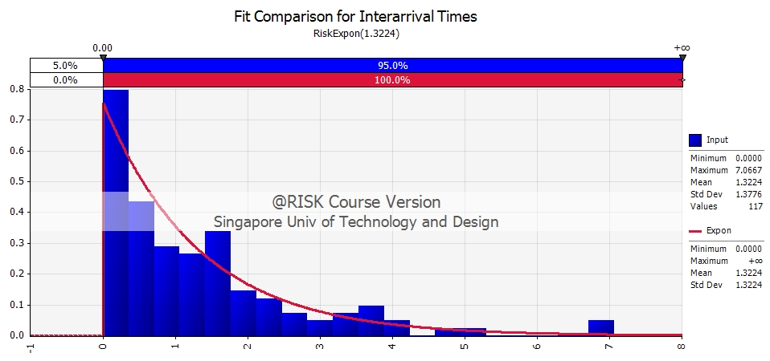

Based on the SCOV value and the appearance of the histogram, the arrival distribution is most likely to be ***exponential*** as it has a SCOV close to 1 and the actual distribution of interarrival times fit the exponential distribution well. In addition, based on the fit comparison results by @RISK, the exponential distribution gives the lowest AIC (Akaike Information Criterion) values of all the distributions tested. The AIC values are given below:

|  |  |
| --- | --- |
| Distribution Tested | AIC Value* |
| Exponential | 301 |
| Pareto2 | 303 |
| Triangular | 366 |

*The lower the AIC value, the better the model fits the data, minimising information loss.

In conclusion, the customer interarrival times are exponentially distributed with a rate of 0.7562 customers per minute.

Service Times

|  |  |
| --- | --- |
| Mean (mins) | 1.1715 |
| S.D. (mins) | 0.8215 |
| SCOV (*Cs* ) | 0.701238 |
| Mean service rate, 𝜇 (customers per min) | 0.8536 |

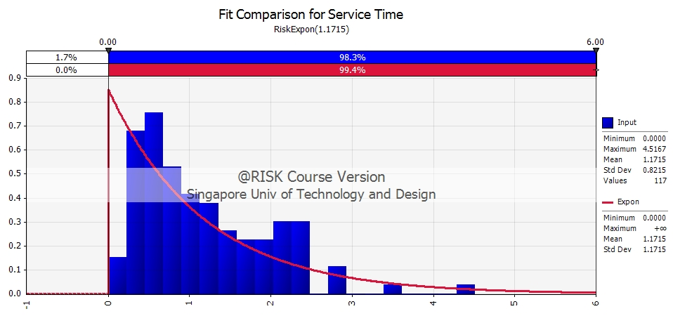

Intensity = λ / 𝜇 = 0.8859

* 1. Interarrival times:
  + Mean(mins) = 1.3224 mins
  + SD(mins) = 1.3776 mins
  + SCOV (Ca) = 1.3776 / 1.3224 =1.0417
  + Interarrival distribution = Exp( 1/1.3224 ), 0.7652 customers per min
  + AIC Values (lower is better)
    - Expon 301
    - Pareto2 303
    - Triang 366
* 2. Service Times:
  + Mean(mins) = 1.1715
  + SD(mins) = 0.8215
  + SCOV (Cs) = 0.8215 / 1.1715 = 0.7012
  + Interarrival distribution = Exp( 1/1.1715 ), 0.854 customers per min
  + AIC Values (lower is better)
    - Expon 273
    - Pareto2 275
    - Triang 280

**SO, This is a M/M/1 Queue.**

* 3. Mean time in system (use formula for M/M/1): 1/(miu-lambda) 10.27 mins
* 4. Mean time in system from time stamp data: 7.93 mins
* 5. 3. vs 4. why?: Because the distribution fitting is not exact.

**IF Service time is a general distribution**

M/G/1 queue

$W=\frac{1}{μ}+\frac{λ(1+C_{s})}{2μ^{2}(1-ρ)}$

$ρ=\frac{λ}{μ}=\frac{0.7652}{0.854 }=0.896$

$W=\frac{1}{0.854}+\frac{0.7652(1+0.7012)}{2{(0.854)}^{2}(1-0.896)}=1.171+\frac{0.7652(1.7012)}{1.459(0.104)}$

$=1.171+\frac{1.302}{0.1517}=1.171+8.583=9.754$